They are NOT a traditional insurance company.
SafetyCulture Care’s core philosophy is “prevent incidents instead of only paying claims.”
Their offering combines:
- Insurance
- Risk management
- Workplace safety technology
Their goal is to stop accidents before they happen, not just insure them. If you propose AI ideas, frame them as:
Predict → Prevent → Protect
SafetyCulture’s vision:
Risk detection → Prevention → Fewer accidents → Lower claims
Their platform helps businesses:
- perform inspections
- train workers
- report safety issues
- monitor workplace conditions
👉 This means predictive AI fits perfectly with their vision.

The parent company SafetyCulture runs a global workplace operations platform used by ~85,000 organizations worldwide.
This platform collects massive data such as:
- safety inspections
- incident reports
- worker observations
- compliance checks
- training completion
- equipment maintenance
- sensor data
They even process billions of safety checks per year.
👉 This means your pitch should emphasize:
“We can unlock value from your safety data.”
SafetyCulture Care primarily focuses on:
• small and medium-sized businesses
• construction companies
• manufacturing firms
• hospitality businesses
• logistics companies
These industries have high workplace injury risk.
Their platform focuses heavily on frontline workers such as:
- construction workers
- factory workers
- field technicians
- hospitality staff
The company wants to serve millions of frontline workers globally.
👉 This means:
They care about practical operational tools
1️⃣ You can unlock insights from their massive safety dataset
2️⃣ You can predict workplace risk before accidents happen
3️⃣ You can reduce insurance claims using AI
4️⃣ You can build intelligent insurance products
5️⃣ You can integrate with their existing platform

SafetyCulture already has the world’s largest operational safety dataset.
With AI, this dataset can become the global predictive engine for workplace risk.

Questions –
Key questions:
• How are you currently managing inspection and safety data?
• Do you already have predictive analytics models in place?
• What tools do you use for data engineering and data science?

USECASES
Predictive Workplace Risk Intelligence
1. Workplace Injury Prediction
ML model predicting probability of injuries using:
- inspection data
- hazard reports
- worker activity
- historical incidents
Output:
Risk score per workplace.
Value:
Prevent accidents before they happen.
2. Accident Hotspot Detection
AI identifies:
- risky locations
- dangerous shifts
- unsafe equipment
Used for proactive alerts.

4. Near-Miss Prediction
Near-miss incidents are leading indicators of accidents.
AI analyzes:
- inspection comments
- safety observations
to predict future accidents.

Workers’ Compensation Intelligence
These are extremely valuable for insurers.
5. Claim Severity Prediction
ML predicts claim cost immediately after injury.
Categories:
- low severity
- medium severity
- catastrophic
Helps prioritize claim management.

6. Claim Fraud Detection
ML detects suspicious claims patterns such as:
- repeated injury patterns
- abnormal treatment costs
- suspicious claim timelines
Fraud detection is very attractive for insurers.

7. Claim Processing Automation
AI extracts information from:
- medical reports
- incident forms
- claim documents
Reduces manual claim processing.
Safety Operations Intelligence
These use cases improve workplace safety.
9. Intelligent Safety Inspection Analysis
AI automatically analyzes inspection results and generates:
- safety insights
- improvement suggestions
- compliance alerts

10. PPE Compliance Detection (Computer Vision)
Using camera feeds or photos.
Detect:
- missing helmets
- missing gloves
- safety violations
Used in construction or factories.

11. Equipment Failure Prediction
Using sensor data and maintenance logs.
AI predicts:
- machine failure
- equipment hazards
Prevents accidents.

12. Worker Risk Profiling
Analyze behavior patterns such as:
- safety violations
- training participation
- incident involvement
Identify high-risk worker groups.

AI Assistants (LLM Applications)
These are modern and attractive.
13. Safety AI Copilot
An AI assistant that answers questions like:
“Is it safe to use this equipment?”
AI references safety manuals and compliance guidelines.

14. Incident Investigation AI
Upload incident report.
AI automatically generates:
- root cause analysis
- prevention recommendations

15. Compliance Intelligence
AI tracks regulatory compliance across regions.
Alerts companies when they are at risk of violating safety regulations.

Insurance Product Innovation
These are strategic use cases that executives like.
16. Smart Insurance Pricing
Insurance premium adjusts dynamically based on:
- safety score
- inspection results
- risk profile
Safer companies pay lower premiums.

17. Portfolio Risk Forecasting
AI forecasts risk across industries like:
- construction
- logistics
- manufacturing
Helps insurers plan strategy.

18. Safety Benchmarking Platform
Compare companies across industries.
Example:
Construction Company A vs Industry Safety Score.
This becomes a new SaaS product.
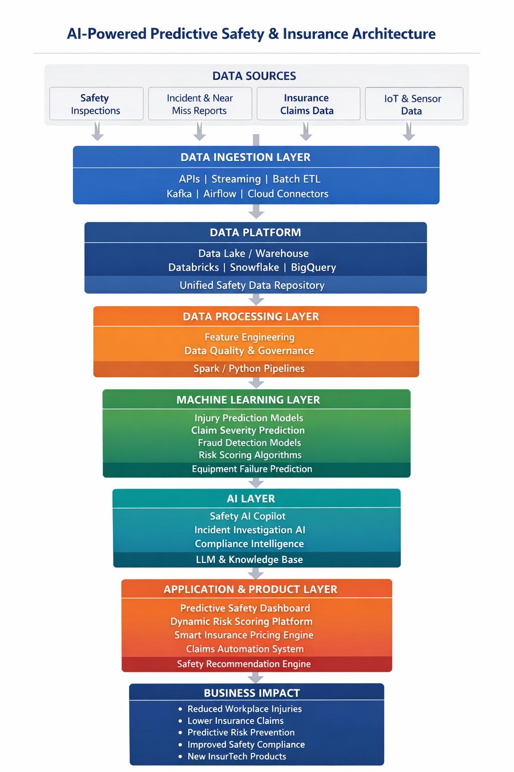sss

